**Lab 1 -- Using Wireshark to look at ICMP packets**

due 9/12 ….And be ready for a quiz in lab on 9/13

1. Access the Virtual Lab through Horizon Client
2. Bring up a command prompt
3. Type in the next command, **but don’t hit enter** yet (If you do accidently hit enter, then you will not get the DNS packets in the sniff)

ping www.guimp.com

1. Don’t close the window …. But bring up Wireshark and start listening on the Ethernet interface
2. **Now** switch back to **cmd prompt** and hit enter to ping the website
3. **Quickly** go back to Wireshark and **stop the sniff** and **save it** as

Lab1-*section#*-*yourname*-Windows_icmp.pcap on your desktop

1. Now, explore the sniff capture and apply a filter to only show the packets with the ICMP protocol : ip.proto == ICMP
2. Screenshot the filtered packet results and place the picture in here :



1. Now let’s explore the first ICMP packet in depth. Still in Wireshark, highlight one of the ICMP packets where you are the source IP. Look in the detail section (in the middle), and answer the following:

What is the Frame size in bytes ? _16955_______

What is the **actual** source MAC? ____00:50:56:aa:3e:ba_____________________

What does shark identify as the “vendor” portion of the source MAC? ____VMWare__________

What is the **actual** destination MAC? _____00:1e:79:74:3c:00____________________

What does shark identify as the “vendor” portion of the destination MAC? ___Cisco___________

Expand the Internet Control Message Protocol header.

What is the ICMP Type number ? __8_____ and associated meaning ? ___(Echo (Ping) Request)_____________

Expand the Internet Protocol header.

What is the value of **Time to live** ? ___128________

Describe the payload data : The payload data has 32 byes. In ASCII it has a couple letters of the alphabet, first in order then random and the last few letters spell ‘hi.’

Here is the screenshot

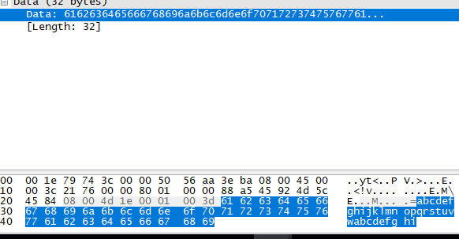

1. Now let’s explore the ICMP packet response in depth. Highlight the ICMP packet where you are the destination IP. Look in the detail section (in the middle), and answer the following:

Expand the Internet Control Message Protocol header.

What is the ICMP Type number ? ___0____ and associated meaning ? __(Echo(ping)Reply)______________

Expand the Internet Protocol header.

What is the value of **Time to live** ? ______52_____

Did the payload data change? ___No_________

1. Save this updated Word file with your responses as

Lab1-*section#*-*yourname*-Windows_icmp.docx on your desktop

1. Attach the the pcap file from Step 6, and your updated docx file to the Assignment